**July 23**



salah tawafsha

Instructor: Dr.

Section: 2

COMP438  
Digital Forensic

Contents

1. Pre-Solving 2

1.1. Create an image for a certain directory 2

# Pre-Solving

## Create an image for a certain directory

1. Open FTK Imager
2. Select Create disk image

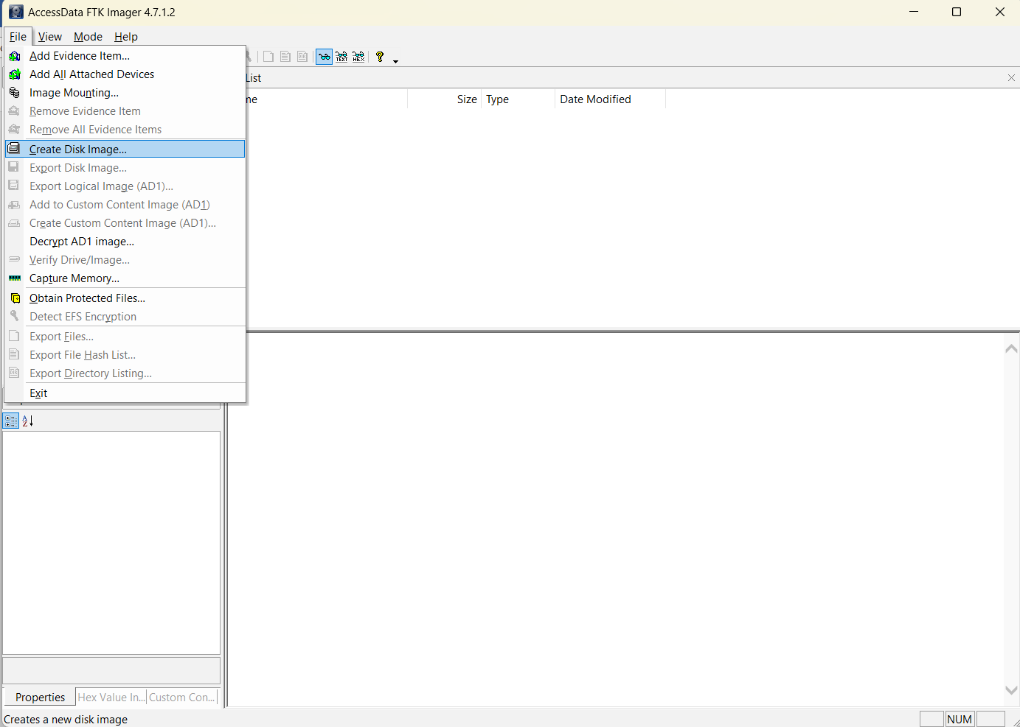

1. Select Logical Drive  
   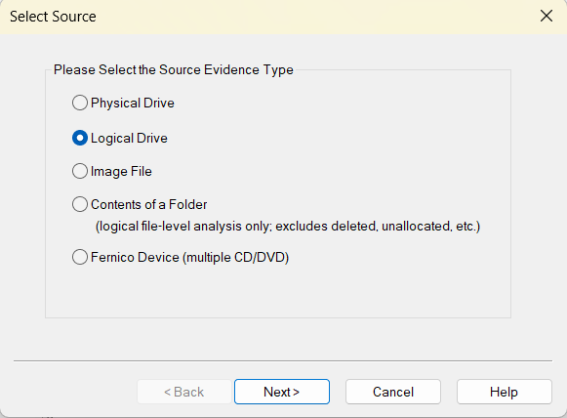
2. Select Disk and click on Finish  
   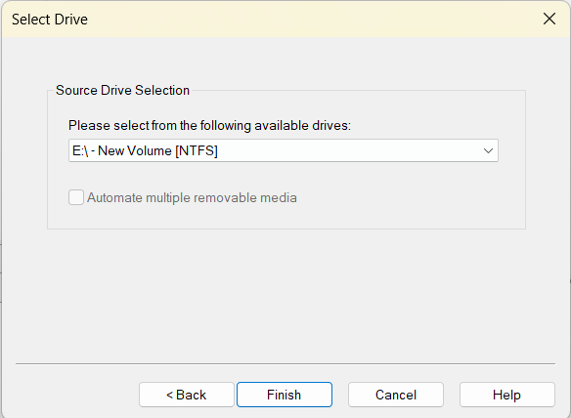
3. Now, we want to add destination that to save the image. So, click on “add”.  
   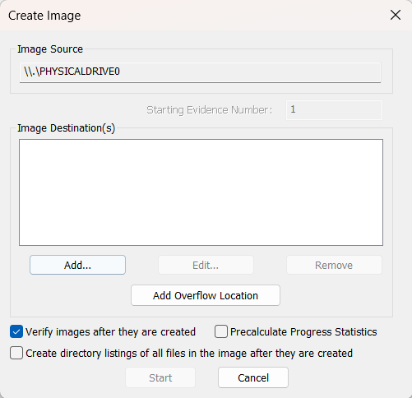
4. Select Raw   
   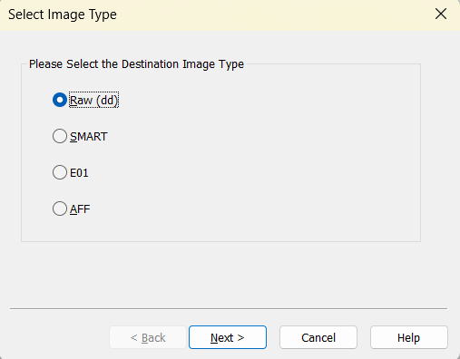
5. enter key information about the evidence item and click “next”. I add this information.   
   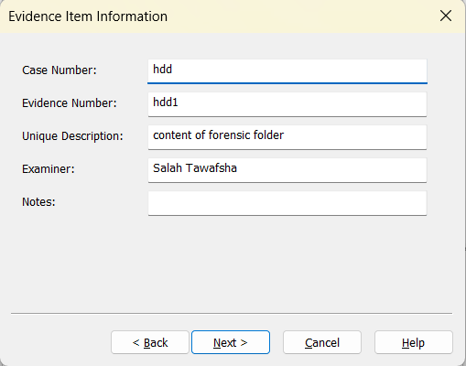
6. Now, click on browse to select folder to save image, type the filename and enter image fragment size, Image Fragment Size indicates the size of each fragment when you want to break a larger image file into multiple parts. Note that: in Raw files, compression is always 0. Finally, click “Finish”.  
     
   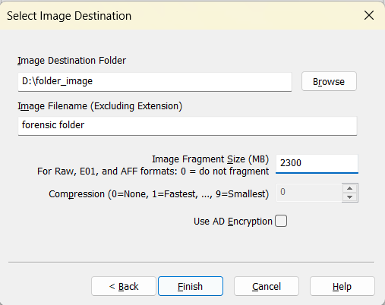
7. Finally, click on start and image will start generating. And when finished we can show summary about the image.   
   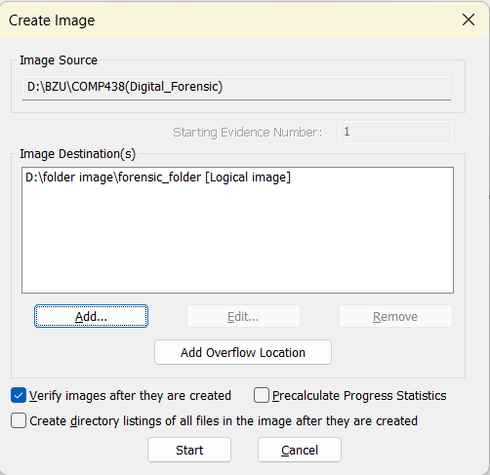

# Python code to search for files based on its signature